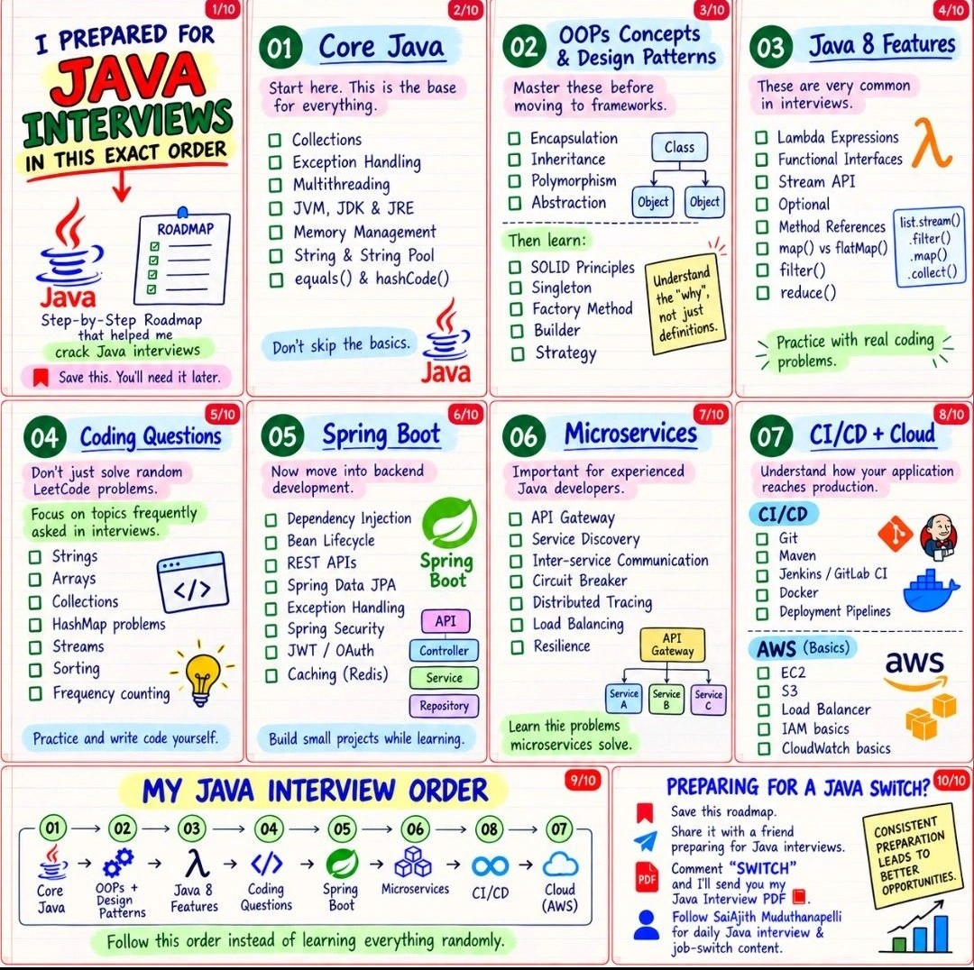
Linux,basic scripting,docker,
kubernetes,ci/cd,jenkins
api connect, apps lunch cloud,

For Industry ready
1].Basic programming logic(loops,variable,fuction,data Structure)
2].Problem-solving and debugging(read error codes, understanding errors, use debug)
3].Version control - git/GitHub (push/pull, Merging Branches, conflict management)
4]. Using the Command Line (Running basic commands, navigating folders, navigating paths, opening folders)
5].How to work the internet (basic networking,http//:, rest api.s,)
6].Databases SQL
7].Automated testing (proper test cases)
8]. Security ()
9]Reading official documentation
10]. Communication

Overview of Java
1]. What is Java?
- A high-level, platform-independent, object-oriented programming language developed by
Sun Microsystems (now owned by Oracle).
- Java was developed in 1991 and released in 1995
- Note: Oracle Corporation acquired Sun Microsystems in 2010. Since then, Java has been
licensed and maintained by Oracle Corporation.

2]. If you have compiled the Java code in window machine, would you be able to run it on Linux?
- Yes, using the “ Write Once, Run Anywhere" (WORA) principle has been a game-changer. Applications built on Windows servers can seamlessly run on Linux-based servers without modification.

3]. What is WORA, and how does Java achieve it?
- The "Write Once, Run Anywhere" (WORA) principle has been a game-changer. Applications built on Windows servers can seamlessly run on Linux-based servers without modification.

4]. Explain the significance of Java being platform-independent.
- Java is platform-independent because a Java program can run on different operating systems using the JVM (Java Virtual Machine) without changing the code.
- Runs on different operating systems – Java programs can run on Windows, Linux, and Mac.
- No need to rewrite code – The same Java program can be used on different platforms.
- Saves time and cost – Developers don't need to create separate programs for each OS.
- JVM makes it possible – The JVM converts Java bytecode into instructions understood by the operating system.
- Write Once, Run Anywhere – This is the main benefit of Java's platform independence.

Your First Java Code: Hello World

public static void main(String[] args)
- public → JVM can access the main() method from anywhere.
- static → JVM can run main() without creating an object of the class.
- void → main() does not return any value.
- main() → This is the starting point of a Java program. JVM starts executing the program from main().
- String[] args → It is used to receive command-line arguments given when running the Java program.

- Easy way to remember:
- public → access
- static → no object
- void → no return
- main → starting point
- String[] args → command-line input

6] System.out.println("Welcome to the Kodewala!");
- System → A predefined Java class.
- out → Used to send/output information to the screen.
- println() → Prints the message on the screen and moves to the next line.

- Easy to remember:
- System → Class
- out → Output
- println() → Print + New Line

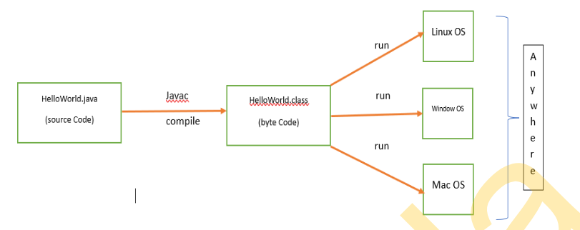
- 1 Why is the main() method static?
→ So the JVM can call main() without creating an object.

- 2.Can we run a program without the main() method?
→ Normally, No. The JVM needs main() as the starting point of a Java application.

- Commands to compile and run Java program:
→ Compile: javac Hello.java
→ Run: java Hello

- Purpose of String args[]:
→ It is used to receive command-line arguments.

- Explain System.out.println():
→ System = Java class
→ out = output to screen
→ println() = prints the message and moves to the next line.

- File Name vs Class Name:
→ If the class is public, the file name must be the same as the class name.
Example: public class Hello → Hello.java

- How many .class files are created for each .java file?
→ One .class file is created for each class in the Java file.
Example: If one .java file has 3 classes → 3 .class files.

JDK, JRE, and JVM
1. JDK — Java Development Kit
- JDK is used to develop Java programs.
- It contains JRE + development tools.
- It includes the Java compiler javac.
- The compiler converts:
.java source code → .class bytecode
- It also includes tools for debugging, packaging, documentation, and other development tasks.
Easy definition:
👉 JDK provides tools to develop, compile, and run Java programs.

2. JRE — Java Runtime Environment
- JRE is used to run Java programs.
- It contains the JVM + Java libraries and supporting files.
- It does not provide the main development tools such as javac.
- If you only want to run an already-compiled Java application, the runtime environment is what is needed.
Easy definition:
👉 JRE provides the environment required to run Java programs.

3. JVM — Java Virtual Machine
- JVM runs Java programs.
- It takes the bytecode (.class file) and executes it.
- JVM is different for different operating systems.
- For example, Windows has a Windows JVM, and Linux has a Linux JVM.
- JVM helps Java achieve platform independence.
- It allocates memory required for program execution.
- JVM de-allocates memory when it's no longer needed.
Easy definition:
👉 JVM is the machine that runs Java bytecode.
- When is JRE sufficient?
  - JRE is enough when you only want to run Java applications.
  - You don't need JDK for just running a program.

- When is JDK required?
  - JDK is required for developing Java programs.
  - It is needed to write, compile, and debug Java code.

- Can we install JRE without JDK?
  - Yes.
  - JRE can be installed separately when you only need to run Java applications.
  - However, modern Java distributions often package Java differently, so the exact installation options depend on the Java version/vendor.

- Application works on one system but fails on another, even though both have JRE. What could be the problem?
  - The two systems may have different Java versions.
  - There may be different environment/configuration settings.
  - Required Java libraries or dependencies may be missing.
  - Simple answer: Check whether both systems have the same Java version and required dependencies.

Command Line Arguments in Java

1].What is Command Line Argument.
- Command Line Arguments are the values passed to a Java program when the program is started, and they are stored in the String[] args array.
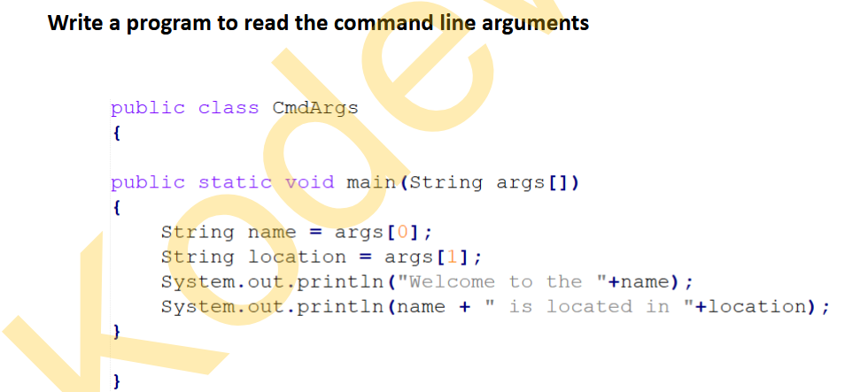

2]. If you are creating a file-reading application, you can give the file name or file path as a command-line argument.
Example:
java ReadFile data.txt
3]. If you are creating a calculator application, the user can pass numbers as command-line arguments when running the program.
Example:
java Calculator 10 20
4]. If you feel that any input may change in future, like data, filename etc. Use the command line arguments.
- If some input may change in the future, such as a file name, number, or data, we can use command-line arguments instead of writing the value directly in the program.
Example:
java ReadFile data.txt
[]java ReadFile newdata.txt
1]. If you are developing the utility to read the file. What would be your approach to read the path, considering the path may change in future
Simple Interview Answer
I would take the file path as a command-line argument because the path may change in the future. This allows the user to provide a different file path without changing the Java code.
Example:
java ReadFile "C:\data\file.txt"
Here, the file path is stored in args[0].

2]. What will happed if you are readding the command line arguments but not passing them?
- If command-line arguments are not passed and we try to access them, ArrayIndexOutOfBoundsException will occur.

3]. How will you make sure that command line arguments are passed and in case user missed to pass the args, throw the warning. i.e “Please enter the input
- We can check whether arguments are passed using args.length.
if (args.length == 0) {
System.out.println("Please enter the input");
} else {
System.out.println("Input: " + args[0]);
}

Java Identifiers
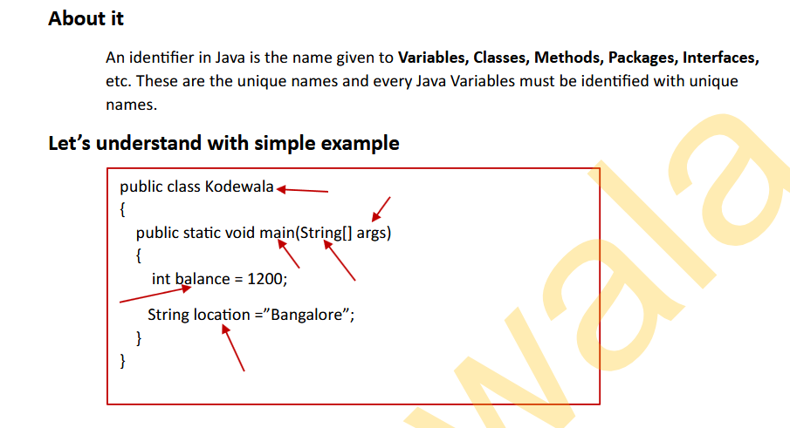

1]. Write a program to display employee details provided through command-line arguments,ensuring adherence to Java naming conventions.
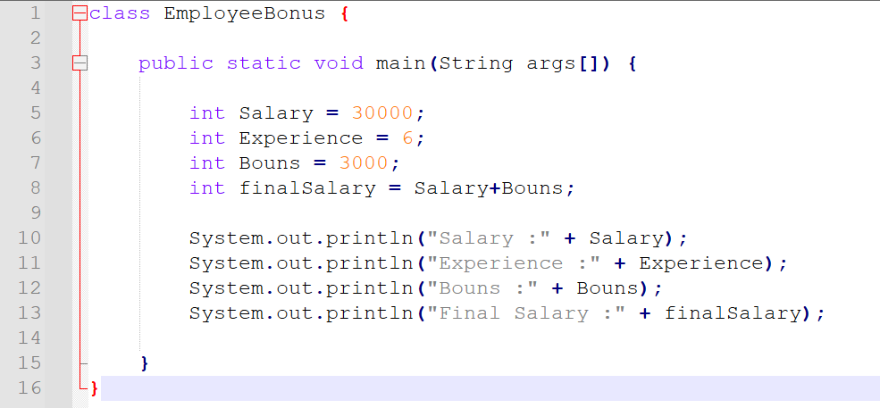
2]. Write a program demonstrating the use of various conventions and rules for naming identifiers.
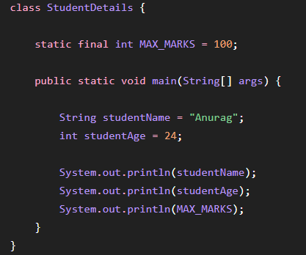

Java Data Types
Primitive Data Type:
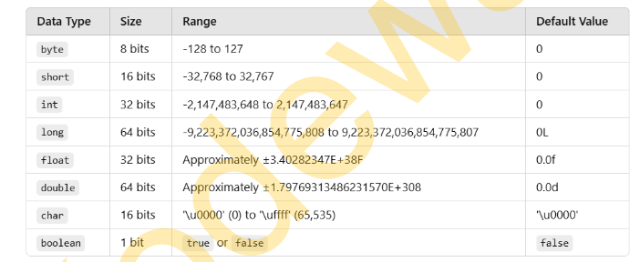

1]. in a large scale application memory usage is a concern, how would you decide between using int and long for storing numerical values?
- Use int when the number is within its range.
- Use long when the number can be very large.
- int uses 4 bytes, while long uses 8 bytes.
- For millions of values, int can save memory.
- Always choose based on range and future growth to avoid overflow.
2]. ✓ Suppose you are developing a system that tracks millions of user data, including large numerical identifiers. Which data type would you choose for user IDs, and why?
- I would choose long for user IDs.
- User IDs can become very large when there are millions or billions of users.
- long can store much larger numbers than int.
- It helps avoid overflow as the system grows.
- Example:
- long userId = 987654321012345L;

Java Data Types (Non-Primitive)
1]. What is the default value of a non-primitive variable?
Class work
- The default value of a non-primitive (reference) variable is null when it is an instance or class variable.
2]. Write a program to explore the non-primitive data types default value.
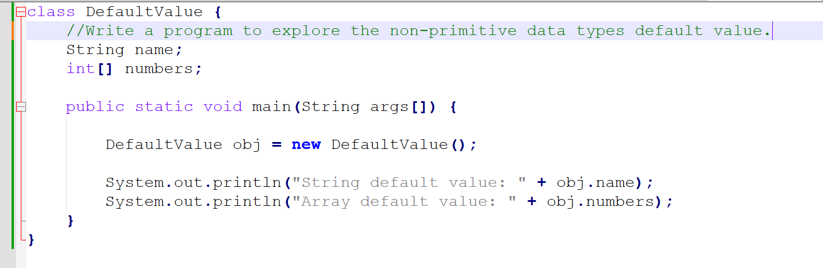

Output; String default value: null
Array default value: null
3]. Write a program to check if the non-primitive data type has null value or not.
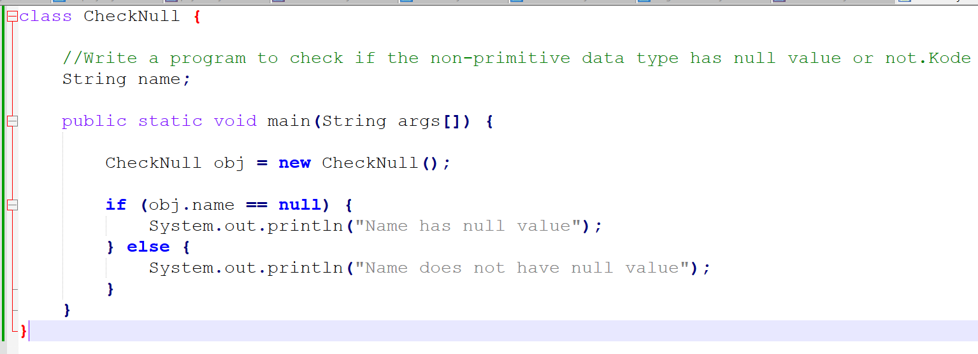

Java Variables

1]. A variable in Java is a named memory location used to store data that can be used and changed while a program is running.
Variables are used to:
- Store data.
- Reuse data in a program.
- Change data during program execution.
- Perform calculations.
- Pass data between methods and objects.
2]. Types of Variables in Java
Java variables are mainly divided into 3 types:
- Local Variable
- Instance Variable
- Static Variable

Local Variable
A variable declared inside a method, constructor, or block is called a local variable.
- • Local variables belong to the method/block where they are declared.
- • They cannot be accessed outside that method/block.
- • They do not have default values.
- • They must be initialized before use.
- • Their lifetime is limited to the execution of that block/method.

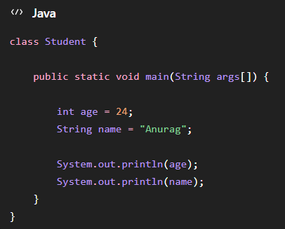

2. Instance Variable
A variable declared inside a class but outside methods, constructors, and blocks is called an instance variable.
• Instance variables belong to an object.
• Every object gets its own copy.
• They are declared inside the class but outside methods.
• They automatically receive default values.
• They can be accessed using an object.

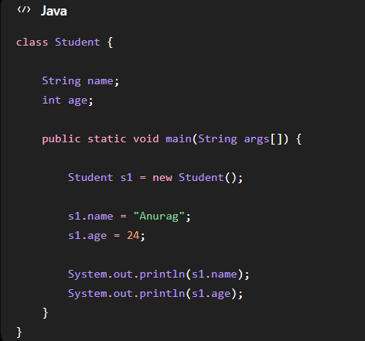

3. Static Variable
A variable declared using the static keyword is called a static variable.
• Static variables belong to the class, not individual objects.
• Only one shared copy normally exists for the class.
• They can be accessed using the class name.
• They are created/associated with the class rather than each object.
• They are useful for values shared among objects.
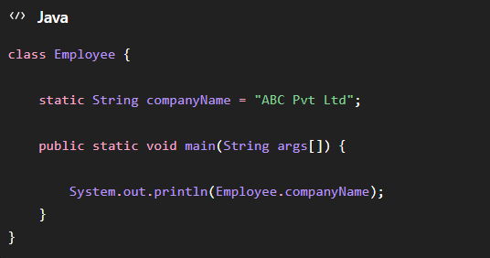

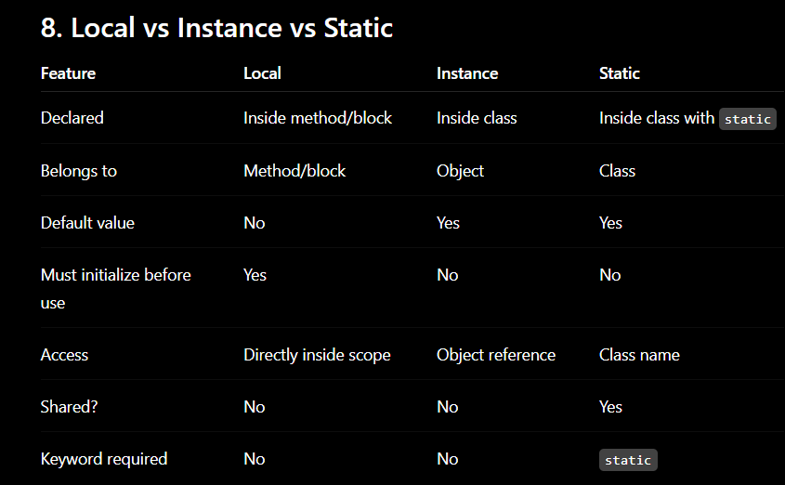
1. How does the JVM manage memory for instance and static variables?
Important points of instance variable
- Instance variables are associated with individual objects.
- They are stored as part of the object's state in heap memory.
- Each object has its own instance-variable values.
Important points of Static variable
- Static variables are associated with the class.
- They are shared among instances of that class.
- The JVM manages their actual memory details; modern JVM implementations may use different physical memory areas internally, so don't rely on the old simplified rule that "all static variables are always in the method area."

2.Can a static method access an instance variable directly? Why or why not?
Answer: No
A static method cannot directly access an instance variable.
class Student {
int age = 24;
static void display() {
System.out.println(age); // ERROR
}
}
Because:
- A static method belongs to the class.
- An instance variable belongs to an object.
- A static method can execute without creating an object.
- Therefore, Java doesn't know which object's instance variable you want to access.
3.How would you use static variables to count the total number of objects created for a class?
This is a very common interview question.
Use a static counter because the counter needs to be shared by all objects.
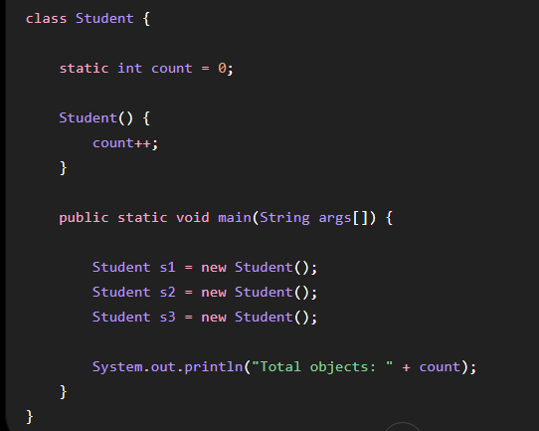

4.What happens if an instance variable and static variable have the same name?
Yes, Java allows this.
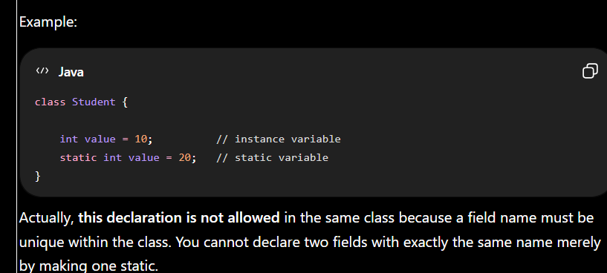

Scope of Variables
In java there are mainly two category of variables, Member Variable (Instance and Static) and Local Variables.

Member Variable (Class Variable):
- These variables should be declared within the class but outside of any method. They can be accessed directly from anywhere within the class.
- We can declare member/class variable anywhere in class, but outside methods.
- Access specified of member variables doesn’t affect scope of them within a class.
- Member variables can be accessed outside a class with following rules.

2. Scope and Lifecycle of Local Variables
- Local variables are declared inside a method, constructor, or block.
- Their scope is limited to the method or block in which they are declared.
- They cannot be accessed outside their defined scope.
- Their lifecycle begins when the method or block starts executing and the variable is created.
- Their lifecycle ends when the method or block finishes execution.

3]. Why Can't Local Variables Have Access Modifiers?
- Access modifiers like public, private, and protected are used to control access to class members.
- Local variables are already restricted to their method, constructor, or block.
- They cannot be accessed from outside their defined scope.
- Therefore, access modifiers are not required for local variables.
- Java does not allow access modifiers with local variables; using them causes a compilation error.

Java Operators (Commonly Used in Industry)
Operators are special symbols that perform operations on variables or values.
Assignment Operator:
Assignment (=) operator is used to assign a value to any variable. Value given on the right-hand side of the operator is assigned to the variable on the left.
Ralational Operator:
Relation operator are used to compare values, such as checking if they are equal, greater than, or less than. They return a true or false result after the comparison and are commonly used in loops and if-else conditions.
Here are 6 type of the relational operators which we use generally in the industry.
- == , Equal to.
- != , Not equal to.
- < , Less than.
- <= , Less than or equal to.
- > , Greater than.
- >= , Greater than or equal to.
Logical Operator:
Logical operator are used to perform “AND” and "OR" operations, similar to how they work in digital circuits. They also have a shortcut feature where the second condition is skipped if the result can already be determined from the first.
Logical operator are:
- &&, Logical AND: returns true when both conditions are true.
- ||, Logical OR: returns true if at least one condition is true.
- !, Logical NOT: returns true when a condition is false and vice-versa
Interview Question:-
1]. What happens if the first condition in a logical AND (&&) operation is false?
- If the first condition is false, Java does not check the second condition because the complete result will always be false.

Java Methods
Java Methods are blocks of code that perform a specific task. A method allows user to reuse the code. All methods in Java must belong to a class. Methods expose the behavior of objects.
- Avoid repeating code
- Make programs easier to understand
- Divide a large program into smaller parts
- Reuse code
- Make debugging easier
- Improve code organization
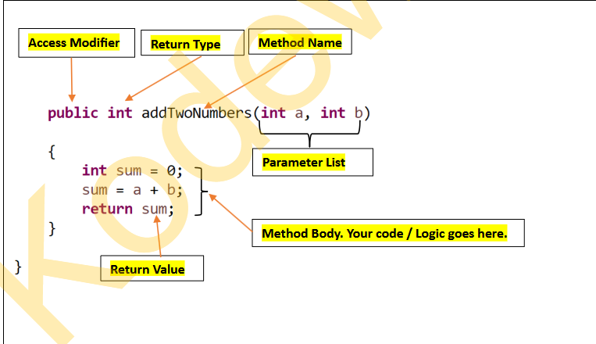

1].static
static means the method belongs to the class, rather than requiring an object to call it,and not need to return type of method.
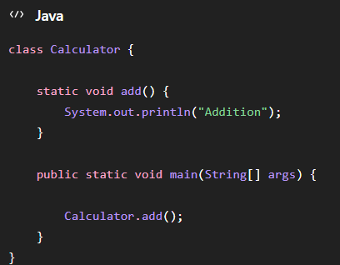
2].Instance Method
A method without static is generally an instance method.
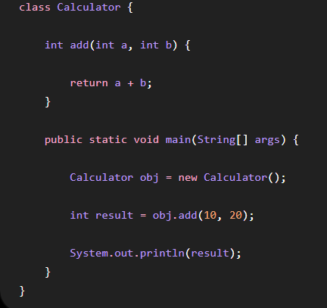

- Method → block of code
- Parameter → input variable
- Argument → actual value passed
- Return type → type of returned value
- return → sends value back
- void → returns nothing
- static → belongs to class
Static Method
- Uses the static keyword.
- Belongs to the class.
- Can be called without creating an object.
- Can have parameters.
- Can return a value.
- Can be overloaded.
- main() is static.
Instance Method
- Does not use static.
- Belongs to an object.
- Usually requires an object to call it.
- Can access instance variables directly.
- Can have parameters.
- Can return a value.
- Can be overloaded.
Method Overloading
- Same method name.
- Different parameter list.
- Can change number of parameters.
- Can change parameter data types.
- Can change order of different parameter types.
- Return type alone cannot overload a method.
- Can happen with both static and instance methods.
- It is an example of compile-time polymorphism.
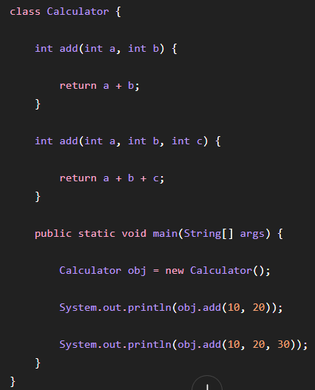

Java Access Modifier
In Java, access modifiers are used to control the visibility and accessibility of classes, constructors, variables, methods, and attributes. They help protect data, control who can access certain parts of a program, and provide security.
Types of Access Modifiers
1. Default – No keyword required → String sayHello()
2. Private → private→ String sayHello()
3. Protected → protected→ String sayHello()
4. Public → public→ String sayHello()
1. public ⭐
public means the member can be accessed from anywhere, as long as the class itself is accessible.
- Accessible from the same class
- Accessible from the same package
- Accessible from a different package
- Accessible through subclasses
- Has the widest accessibility
Think:
public = Everybody can access
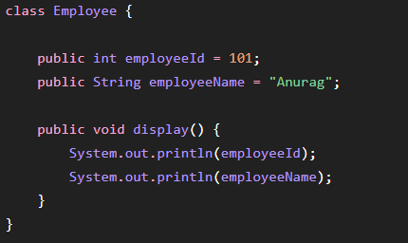
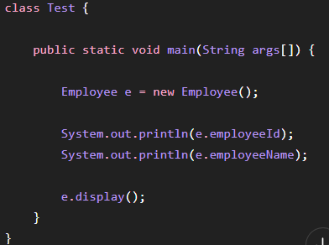

2. private ⭐⭐⭐
private is the most restrictive access modifier.
A private member can be accessed only inside the same class.
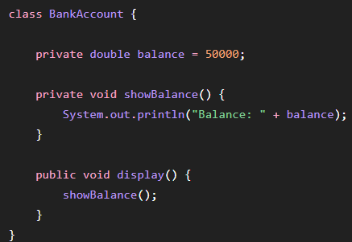
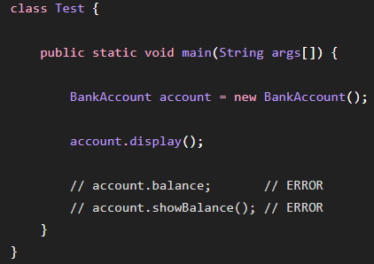

3. Default Access Modifier
When you don't write any access modifier, Java gives the member default/package-private access.
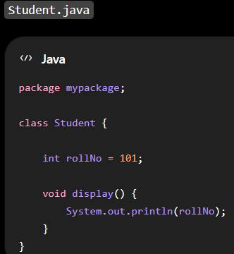
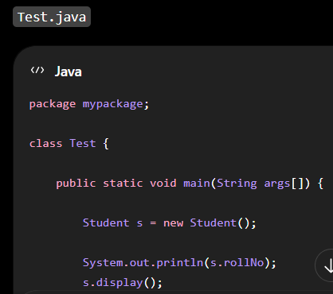

4. protected ⭐⭐⭐
protected is slightly more complicated.
A protected member can be accessed:
- Inside the same class
- Anywhere in the same package
- From a subclass in another package

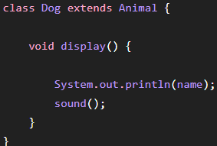
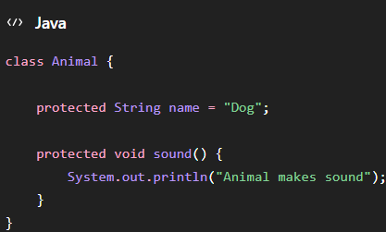

1].Difference between protected and default.
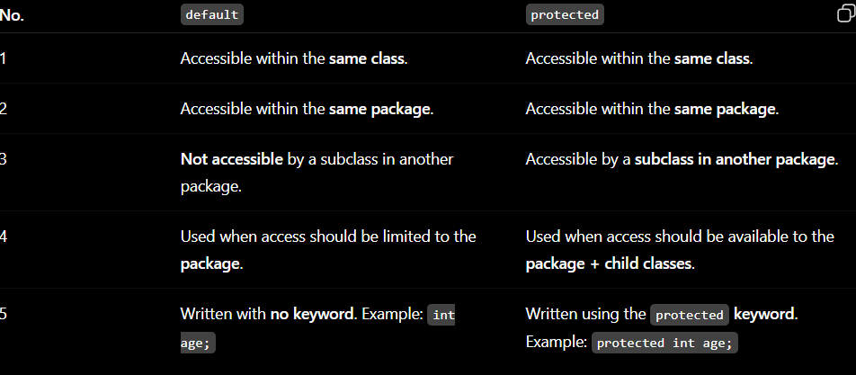

2].Can a private method be overridden?
⭐ Remember
- private methods cannot be overridden. ❌
- They are accessible only inside the same class.
- A child class cannot directly access the parent's private method.
- A same-named method in the child is a new method, not an override.
- @Override will produce an error in this situation.
Interview answer:
A private method cannot be overridden because it is not visible to the subclass.

3]. ✓ How do you allow access within the same package and to subclasses in other packages? Class work
The answer is protected access modifier.

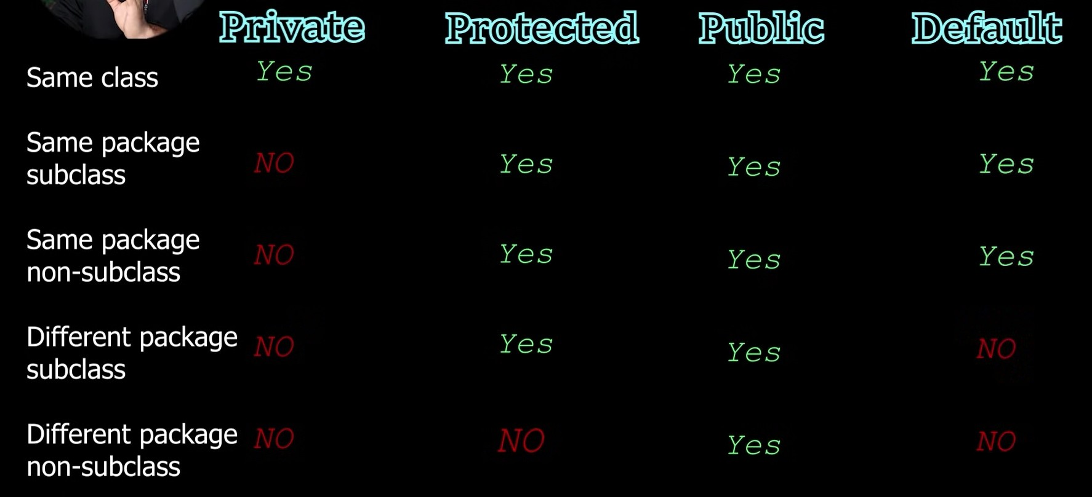

How to Call a Method?
Calling a method/function helps us reuse code and keep our programs organised. In Java, methods are a group of statements that perform a specific task i.e addTwoNumbers(), println() and calculateInterest(), etc., and can return a result. In this session, we will learn how to call different types of methods in Java with a simple real-time example.
1].In the software development industry, methods are used extensively to break down
complex tasks into manageable pieces.
2]. Calling methods is crucial for maintaining clean, reusable, and modular code. Methods such as mathematical calculations, data processing, and utility functions are frequently used in real-world applications.
1. Instance Method (method that belongs to an object)
Let's define a method. Since we are creating it ourselves, it is called a "user-defined method." After defining the method, we will call it (using an object).
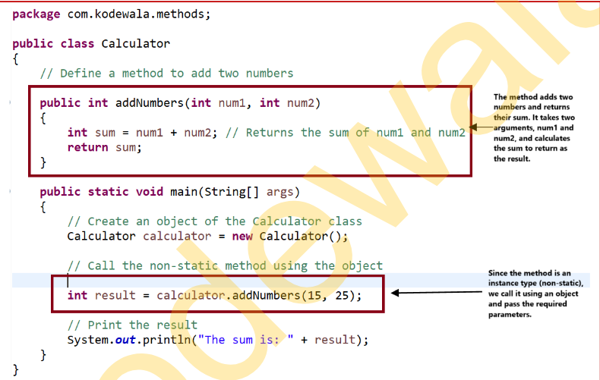

1.Static Method (method that belongs to a class)
Now, let's define a static method. Since it belongs to the class itself, it is called a "static method."
After defining the method, we will call it using the class name.
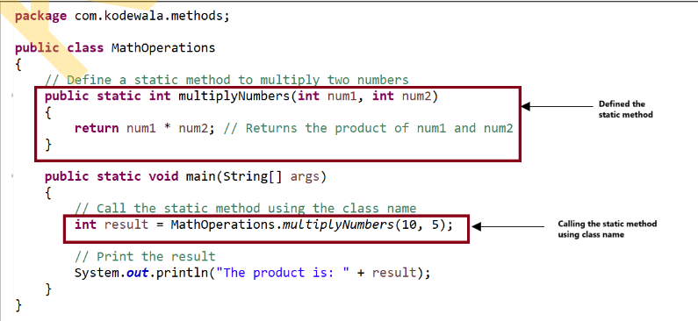

1].What is the difference between calling a static method and an instance method?
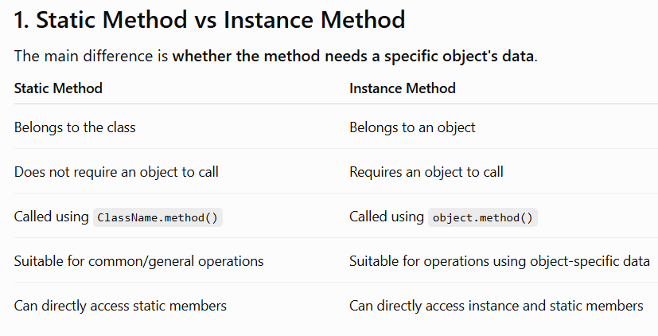
2]. Can you give an example where you would use a static method vs an instance method?
[Hint]: Use static methods for tasks that don't depend on specific object data, and use instance methods when the task needs data from a specific object.
1. Static Method — General Account Operation
Suppose we want to calculate the interest rate offered by the bank.
The interest rate is common for all accounts, so it does not depend on a particular account.
Because the interest rate is a common/general value, not something specific to one account.
2. Instance Method — Specific Account Operation
Now suppose we want to display account details.
Every account can have different:
- Account number
- Account holder name
- Balance
Because displayAccountDetails() needs data belonging to that particular account.

Static vs. Instance Method?
About
In Java, methods are mainly of two types based on their relationship with the class:
1. Static method: This method belongs to the class itself, and you can call it without
creating an object of the class.
2. Instance method: This method belongs to a specific object, and you need to create an object of the class to call it.
- In simple terms, static methods are for general actions related to the class, while instance methods are for actions tied to a specific object
- In industry, static methods are commonly used for utility functions, like calculating tax or logging messages, where the logic doesn’t depend on specific objects. Instance methods are used for operations that modify or interact with specific data, like processing an order or updating a bank account balance.

1]. The interviewer may ask for examples of when to use static methods and whether they can be overridden or not
We use a static method when the operation does not depend on the data of a particular object.
//class
class BankAccount {
static double getInterestRate() { return 7.5; }
}
//object
double rate = BankAccount.getInterestRate();
We don't need to create a BankAccount object because the interest rate is common to the bank, not specific to one account.
Can static methods be overridden?
No, static methods cannot be overridden.
The display() method in Child is not overriding the parent method. It is called method hiding.
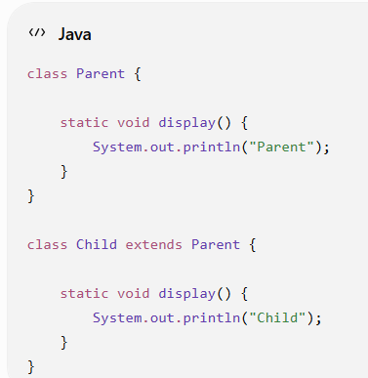

The display() method in Child is not overriding the parent method. It is called method hiding.
Why?
Because:
- Static method → belongs to the class
- Instance method → belongs to an object
- Method overriding depends on runtime object behavior
- Static methods are resolved based on the class, not the runtime object
⭐ Interview-ready answer
I use static methods for common or utility operations that don't require object-specific data, such as calculations, validation, or common configuration. Static methods cannot be overridden because they belong to the class rather than an object. If a child class defines a static method with the same signature, it is called method hiding, not overriding.

2].How would you manage global settings in a class using static methods?
Suppose a bank has settings that are common to every account, such as bank name, interest rate, and minimum balance.
Bank Name: ABC Bank
Interest Rate: 7.5%
Minimum Balance: 1000.0
Why use static?
These settings are common to the entire bank, not specific to one account.
Interview answer
I would use static variables and static methods to manage global settings that are common to all objects of a class. For example, in a banking system, bank name, interest rate, and minimum balance can be static. A static method can be used to access or update these settings without creating an object.

3]. Can you explain how instance methods are used to manage specific object data?
An instance method is a method that works with the data of a specific object.
Each object can have different data, and the instance method operates on that particular object's data.
Interview answer
Instance methods are used to perform operations on data belonging to a specific object. For example, in a BankAccount class, deposit(), withdraw(), and displayAccountDetails() are instance methods because they work with the balance, account number, and account holder of a particular account. Each object maintains its own data, and the instance method operates on that object's data

4].Can an instance method be called without creating an object?
Normally, no. An instance method belongs to an object, so you need an object to call it from a static context such as main().
Normally, an instance method requires an object to be called because it belongs to a particular object. For example, account.displayBalance() requires a BankAccount object. However, one instance method can call another instance method directly because they execute in the context of the same object.

5]. How would you implement a utility function (like a calculation) in a system that doesn’t require object-specific data
Yes. For a utility function that doesn't depend on any specific object's data, I would implement it as a static method.
Interview-ready answer
If I need a utility function that doesn't depend on object-specific data, I would make it a static method. For example, calculation, validation, parsing, or formatting methods can be static. This allows me to call the method using the class name without creating an unnecessary object.
5]. Share some of the examples where you have used static methods in your projects.
- I used static methods for operations that are common to all bank accounts.
- For example, I created a static method to get the bank's interest rate.
- I also used static methods for calculating interest, as they don't depend on a particular account object.
- Account-specific operations like deposit, withdrawal, and balance checking were instance methods.
- Static methods can be called using the class name without creating an object, for example BankAccount.getInterestRate().

Java Constructors
A constructor in Java is a special method that is used to initialise objects. It is called automatically when an object of a class is created. The constructor's main purpose is to set initial values for the object's attributes.
1]. What are Constructors in Java?
- A constructor is a special method used to initialise an object.
- It has the same name as the class.
- A constructor does not have a return type, not even void.
- It is automatically called when we create an object using new.
- Constructors are commonly used to assign initial values to instance variables.
2]. Can a constructor be static?
- No, a constructor cannot be static in Java.
- A constructor is used to initialise an object, while static belongs to the class.
- A constructor is automatically called when an object is created.
- Static members do not require an object, so a static constructor would not make sense.
- If you write static with a constructor, Java gives a compilation error.
3]. What is constructor chaining?
- Constructor chaining means calling one constructor from another constructor.
- It helps reuse constructor code and avoid duplication.
- We use this() to call another constructor in the same class.
- We use super() to call a constructor of the parent class.
- The this() or super() call must be the first statement inside a constructor.
class Account {
String name;
double balance;
Account() {
this("Anurag", 50000);
}
Account(String name, double balance) {
this.name = name;
this.balance = balance; } }
4].Difference between constructor and method
Constructor | Method
1. Used to initialise an object. | 1. Used to perform an operation/task.
2. Must have the same name as the class. | 2. Can have any valid name.
3. Has no return type, not even void. | 3. Can have a return type like int, String, or void.
4. Called automatically when an object is created. | 4. Usually called explicitly using an object or class name.
5. Mainly initialises object data. | 5. Mainly contains the business logic/behavior.

5]. Can a constructor be private?
- Yes, a constructor can be private.
- A private constructor cannot be accessed outside the class.
- It is used when we want to control object creation.
- It is commonly used in the Singleton Design Pattern.
- It can also be used to prevent direct object creation from outside the class.
6]. What happens if you don't define a constructor in the class
- Java automatically provides a default constructor.
- This constructor takes no parameters.
- It calls the parent class constructor using super().
- Instance variables get their default values (0, null, false, etc.).
- If you create any parameterised constructor, Java will not provide the default constructor automatically.
7]. Can a constructor call another constructor in the same class?
- Yes, a constructor can call another constructor in the same class.
- We use the this() keyword for this.
- this() must be the first statement inside the constructor.
- It helps reuse constructor code and avoid duplication.
- This is called constructor chaining.
8]. Can a constructor throw an exception?
- Yes, a constructor can throw an exception.
- We use the throws keyword in the constructor declaration.
- It is useful when an error occurs while initialising an object.
- The calling code must handle or declare the exception.
- Both checked and unchecked exceptions can be thrown from a constructor.

9]. Can we call a constructor explicitly using an object?
- No, we cannot call a constructor using an object.
- A constructor is called automatically when we use new.
- We can call another constructor using this().
- We can call a parent constructor using super().
- Example: Account a = new Account(); automatically calls the constructor.

10]. What is the order of execution in constructor chaining?
- First, the parent class constructor executes.
- Then, the child class constructor executes.
- super() is used to call the parent constructor.
- this() is used to call another constructor in the same class.
- So, execution generally follows parent → child.

11]. What happens if a subclass constructor does not explicitly call super()?
- Java automatically inserts super() as the first statement.
- It calls the no-argument constructor of the parent class.
- The parent constructor executes first.
- Then the subclass constructor executes.
- If the parent has no no-argument constructor, compilation fails.

12]. What is the role of constructors in the Singleton Design Pattern?
- The Singleton pattern allows only one object of a class.
- The constructor is made private to prevent outside object creation.
- A static method is used to provide access to the single object.
- The object is usually stored in a static variable.
- Example idea: Singleton.getInstance() returns the same object

Industry Experience:
✓ In real-world applications, constructors are used to initialize objects with necessary
configurations.
✓ Example: In a banking application, an Account object can be initialized with default values or
user-specific details.

this and super keyword in Java
1]. What is the “this” keyword in Java.
The this keyword in Java is a reference variable that refers to the current object of a class.
- Refers to the current object
- Used to differentiate instance variables and local variables
- Used to call the current class method
- Used to call the current class constructor
- Can be used to pass the current object as an argument
2]. What is the “super” keyword in Java?
The super keyword in Java is a reference variable used to refer to the immediate parent class object.
Used to access the parent class variable
Used to call the parent class method
Used to call the parent class constructor
Used when parent and child have variables with the same name
super() must be the first statement in a constructor

3]. Difference between this and super in Java
this | super
1. Refers to the current object. | 1. Refers to the immediate parent class object.
2. Used to access the current class variables. | 2. Used to access parent class variables.
3. Used to call the current class method. | 3. Used to call the parent class method.
4. this() calls the current class constructor. | 4. super() calls the parent class constructor.
5. Mainly used to resolve conflicts between local and instance variables. | 5. Mainly used when parent and child have the same variable/method name.

Java Arrays

1]. What is an array in Java?
- An array is a collection of the same data type.
- It contains contiguous memory.
- The size of an array is fixed after it is created.
- Array elements are accessed using an index, starting from 0.
- Java arrays are objects.
- Example: int[] arr = {10, 20, 30, 40};

2]. How do you declare an array in Java?
int[] numbers;
int[] numbers = new int[5];

3]. What is the default value of an array element in Java?
The default value of an array element in Java depends on its data type:
- int → 0
- float → 0.0
- double → 0.0
- char → '\u0000'
- boolean → false
- String/objects → null
Example:
int[] arr = new int[3];
The default values are: 0, 0, 0.

4]. What is the difference between an array and an ArrayList?
Array
- An array stores multiple values of the same type.
- An array has a fixed size.
- Its size cannot be changed after creation.
- Arrays can store primitive data types like int, char, etc.
- Arrays use index numbers to access elements.
- Array index starts from 0.
- Arrays can store objects also.

ArrayList

ArrayList is a resizable collection.

Its size can grow or shrink dynamically.

ArrayList stores objects, not primitive types directly.

It can use wrapper classes like Integer instead of int.

It also uses index numbers to access elements.

ArrayList index starts from 0.

We can add elements using add().

We can remove elements using remove().

ArrayList is available in the java.util package.

Example: ArrayList<Integer> list = new ArrayList<>();

5].How do you find the length of an array in Java?
We use the length property to find the size of an array.
Syntax: arrayName.length
It returns the number of elements in the array.
int[] arr = {10, 20, 30, 40, 50};
System.out.println(arr.length);

6].What happens if you try to access an array index out of bount?
- Java throws an ArrayIndexOutOfBoundsException.
- It happens when you try to access an index that does not exist.
- Array indexes start from 0.
- The last index is length - 1.
- Example:
int[] arr = {10, 20, 30};
System.out.println(arr[3]);
Here, valid indexes are 0, 1, and 2.
Index 3 is invalid.
So, Java throws an ArrayIndexOutOfBoundsException.

7]. Can an array in Java hold different data types?
No, a normal Java array cannot store different data types.
- An array stores elements of the same data type.
- For example, an int array can store only int values.
Example:
int[] arr = {10, 20, 30};
You cannot directly store int, float, and String together in an int[].
- However, an Object[] can store different types:
Object[] arr = {10, 10.5, "Hello", true};
In short: Normal array → same data type. Object[] → different types can be stored.

8]. How do you initialise an array in Java?
- An array can be initialized in different ways:
- Using values directly:
- int[] arr = {10, 20, 30, 40};

- Using new keyword:
- int[] arr = new int[4];

- Initialize values after creating the array:
- int[] arr = new int[3];
- arr[0] = 10;
- arr[1] = 20;
- arr[2] = 30 In simple words: Array initialization means assigning values to an array.

9]. What is the purpose of the Arrays.sort() method?
- Arrays.sort() is used to sort the elements of an array.
- It sorts the elements in ascending order by default.
- It is available in the java.util.Arrays class.

- Example:
- import java.util.Arrays;
- int[] arr = {30, 10, 20, 40};
- Arrays.sort(arr);
- System.out.println(Arrays.toString(arr));

For Loop In Java
A for loop in Java is a way to repeat a block of code multiple times. It runs the code as long as a specific condition is true. For loops are useful for going through a range of values, repeating tasks, or working with arrays and collections efficiently.

